EXPERIMENT 1: MATLAB CODE
Title: Simulation-Based Electromagnetic Analysis of TEM, TE and TM Propagation Modes in Microwave Transmission Structures
AIM: To calculate the cutoff frequency and propagation constant of TE₁₀ and TM₁₁ modes in a WR-90 rectangular waveguide and plot their propagation characteristics.

MATLAB program

clc; clear; close all;
% Experiment 1: TE and TM Modes in Rectangular Waveguide c = 3e8; % Speed of light (m/s)
a = 22.86e-3; % Waveguide width (m)
b = 10.16e-3; % Waveguide height (m) L = 100e-3; % Waveguide length (m)
f = 10e9; % Operating frequency (Hz)
% Cutoff frequencies fc_TE10 = c/(2*a);
m = 1;
n = 1;
fc_TM11 = (c/2)*sqrt((m/a)^2 + (n/b)^2);
% Propagation constant
beta_TE10 = (2*pi*f/c)*sqrt(1-(fc_TE10/f)^2); if f > fc_TM11
beta_TM11 = (2*pi*f/c)*sqrt(1-(fc_TM11/f)^2); else
beta_TM11 = 0; end
% Display calculated results
fprintf('Operating Frequency = %.2f GHz\n',f/1e9);

fprintf('TE10 Cutoff Frequency = %.3f GHz\n',fc_TE10/1e9); fprintf('TM11 Cutoff Frequency = %.3f GHz\n',fc_TM11/1e9); fprintf('TE10 Propagation Constant = %.2f rad/m\n',beta_TE10); fprintf('TM11 Propagation Constant = %.2f rad/m\n',beta_TM11);
% Frequency sweep
freq = linspace(5e9,20e9,500); beta1 = zeros(size(freq)); beta2 = zeros(size(freq));
for k = 1:length(freq) if freq(k) > fc_TE10
beta1(k) = (2*pi*freq(k)/c)* ... sqrt(1-(fc_TE10/freq(k))^2);
end
if freq(k) > fc_TM11
beta2(k) = (2*pi*freq(k)/c)* ... sqrt(1-(fc_TM11/freq(k))^2);
end end

% Plot propagation constant figure;
plot(freq/1e9,beta1,'b','LineWidth',2); hold on; plot(freq/1e9,beta2,'r','LineWidth',2); xline(fc_TE10/1e9,'--b','TE10 cutoff'); xline(fc_TM11/1e9,'--r','TM11 cutoff'); xlabel('Frequency (GHz)');
ylabel('Propagation Constant \beta (rad/m)'); title('Propagation Characteristics of TE10 and TM11 Modes');

legend('TE10','TM11','Location','northwest'); grid on;
hold off;
% Illustrative TE10 electric-field distribution x = linspace(0,a,100);
y = linspace(0,b,50); [X,Y] = meshgrid(x,y); Ey = sin(pi*X/a); figure;
surf(X*1000,Y*1000,Ey); xlabel('Width x (mm)');
ylabel('Height y (mm)'); zlabel('Normalized E-field');
title('Illustrative TE10 Electric-Field Distribution'); shading interp;
colorbar;

Expected output (calculated)
Illustrative theoretical values; not measured HFSS results.

Parameter | Expected value
Operating frequency | 12GHz
TE₁₀ cutoff frequency | 6.583GHz
TM₁₁ cutoff frequency | 17.42GHz
TE₁₀ propagation constant at 10 GHz | Approximately 160.2 rad/m
TM₁₁ at 10 GHz | Below cutoff; no real propagating β

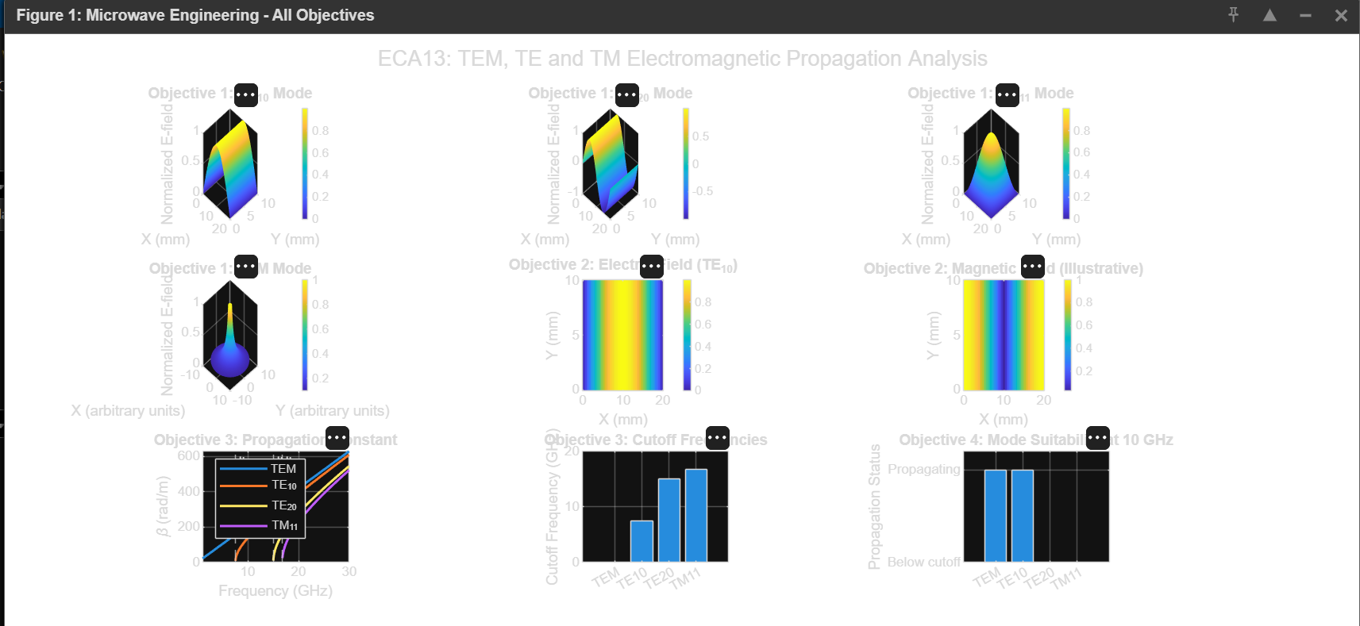

RESULT:
The cutoff frequencies and propagation characteristics of the TE₁₀ and TM₁₁ modes were calculated using MATLAB. At 10 GHz, the dominant TE₁₀ mode propagates, whereas the TM₁₁ mode is below cutoff.

